MD Record Data Analysis
1. Full Features
Notebook: MDRecord_fullfeatures.ipynb
Dataset: IBS_Med_Original_Group_FullFeatures.xlsx

2. Dietary Features
Notebook: MDRecord_DiataryAnalyss.ipynb
Dataset: MDRecord_Diatiary_Cleaned_forAnalysis.xlsx

3. Dietary and Medical Condition Combined
Notebook: MDRecord_Condition_Combine.ipynb
Dataset: MDRecord_Conditions_Analysis.xlsx
MDRecord_Dietiary_Cleaned_forAnalysis.xlsx

I. Full Features
1. Date Preprocessing
The initial dataset, IBS_Med_Original_Group_FullFeatures.xlsx, underwent the following preprocessing steps:
- Initial Data Loading: Data was loaded into a DataFrame df.
- Handling 'n/a' and 'N/A': Case-insensitive 'n/a' and 'N/A' values were replaced with np.nan in df_processed to correctly identify missing data.
- Dropping Columns with Excessive Missing Values: Columns with 30 or more missing values were dropped, resulting in df_cleaned (reduced from 46 to 38 columns). This removed features deemed too sparse for reliable analysis.
- Group-wise Imputation: Missing numerical values were imputed with the median and categorical values with the mode, separately for 'IBS' and 'Control' groups in df_imputed_groupwise. This ensured no missing values remained.
- Feature Engineering (BMI Calculation): Body Mass Index (BMI) was calculated using 'weight' (lbs) and 'height' (inches) from df_imputed_groupwise, with height string values parsed and converted to inches.
- One-Hot Encoding: All categorical features were converted into numerical binary features using one-hot encoding (pd.get_dummies) to create df_encoded. drop_first=True was used to prevent multicollinearity, resulting in a DataFrame with 61 samples and 185 columns (including the target Group_IBS).
- Feature Scaling: For dimensionality reduction and classification, numerical features (excluding the target) were standardized using StandardScaler to create X_scaled.

2. Visualization
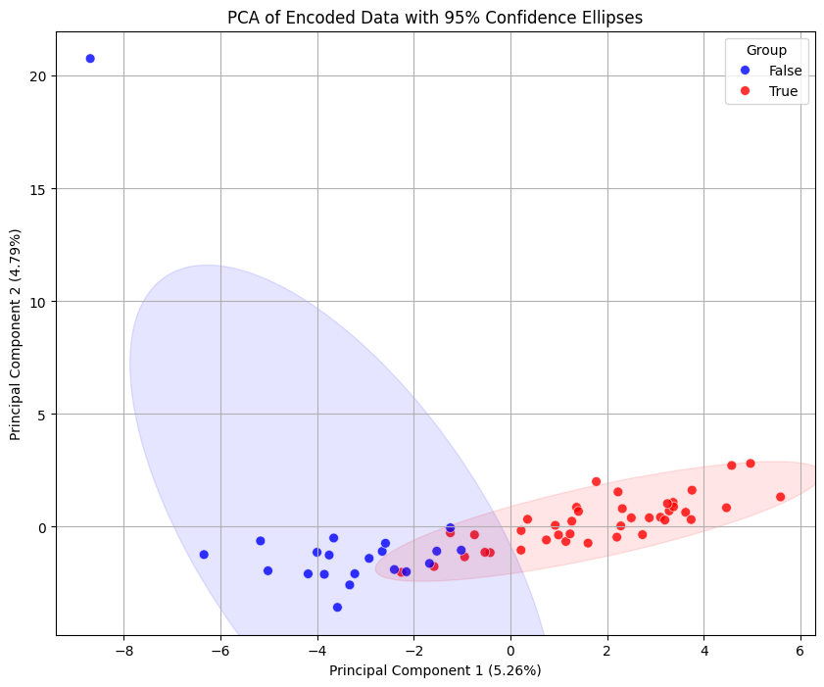

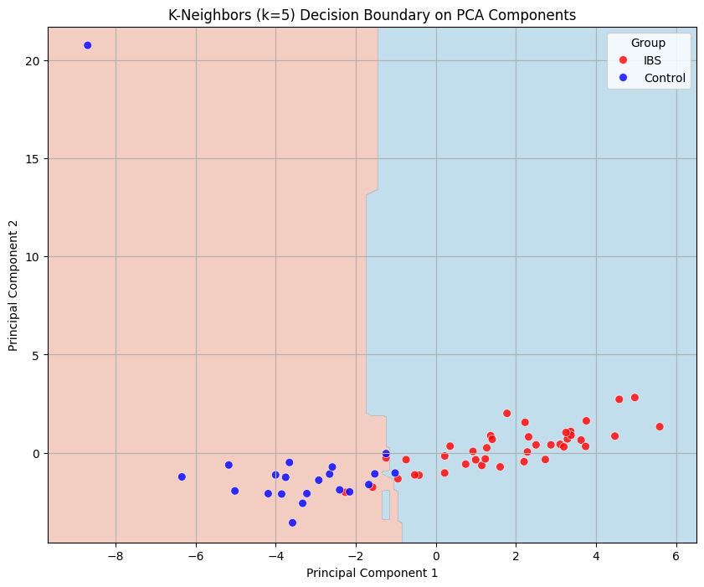K-Neighbors decision boundary plot generated.
3. Machine Learning Classification Accuracy

--- Random Forest ---
Accuracy: 0.947

--- Decision Tree ---
Accuracy: 0.947

--- K-Neighbors ---
Accuracy: 0.632

--- SVM ---
Accuracy: 0.632

--- Naive Bayes ---
Accuracy: 0.842

--- Logistic Regression ---
Accuracy: 0.895

4. Feature Importance Analysis
Top 10 most important features:
 | Feature | Importance
16 | ethnicity/race_Asian American | 0.065415
99 | colonoscopy in the past 5 years_yes | 0.045817
166 | how often were seeds and nuts consumed in the ... | 0.044507
0 | weight | 0.038458
21 | Marital status_Married | 0.029969
165 | how often were seeds and nuts consumed in the ... | 0.027973
106 | diagnosed with anxiety_yes | 0.026384
10 | Educational Level_High school | 0.024593
30 | zipcode (0xxxx)_8021 | 0.023688
104 | dx of depression_yes | 0.020504

II. Dietary Features
1. Data Preprocessing
1) 10 dietary habits features from original MD Record
2) Categorical to Numeral Value
"1 time in the past month": 1,
"2-3 times in the past month": 2.5,
"1-2 times per week": 6,
"3-4 times per week": 14,
"1 time per day": 30,
"2-3 times per day": 75,
"4-5 times per day": 135,
"5-6 times per week": 22,
"3-4 times per week ": 14, # Handling potential extra space
"6 or more times per day": 200,
"none": 0,
"never": 0.1,
"2-3 times in past month": 2.5, #potential different phrasing
"vegetarian": 0, # Assuming 'vegetarian' implies
"1 time per day ": 1 # Handling potential extra space

3) Missing replaced by Mode of each feature column

Top 10 Features by Importance:
Feature Importance
spicy food 0.166976
seeds 0.131296
no lean meat 0.084641
flatulence 0.079856
anxietydiagnose 0.073817
raw food 0.070984
fatty dairy 0.056169
antidepressent 0.053517
dressings 0.052698
depressiondx 0.049480

2. Visualization
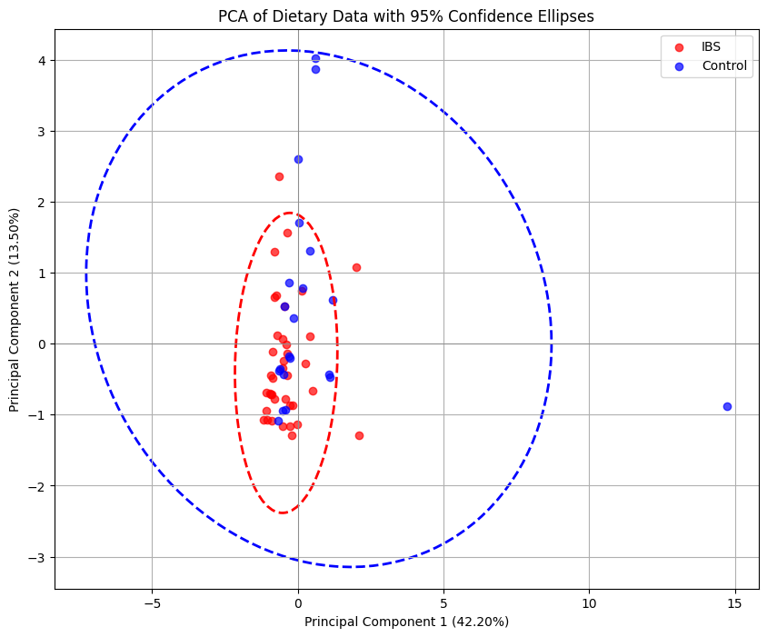
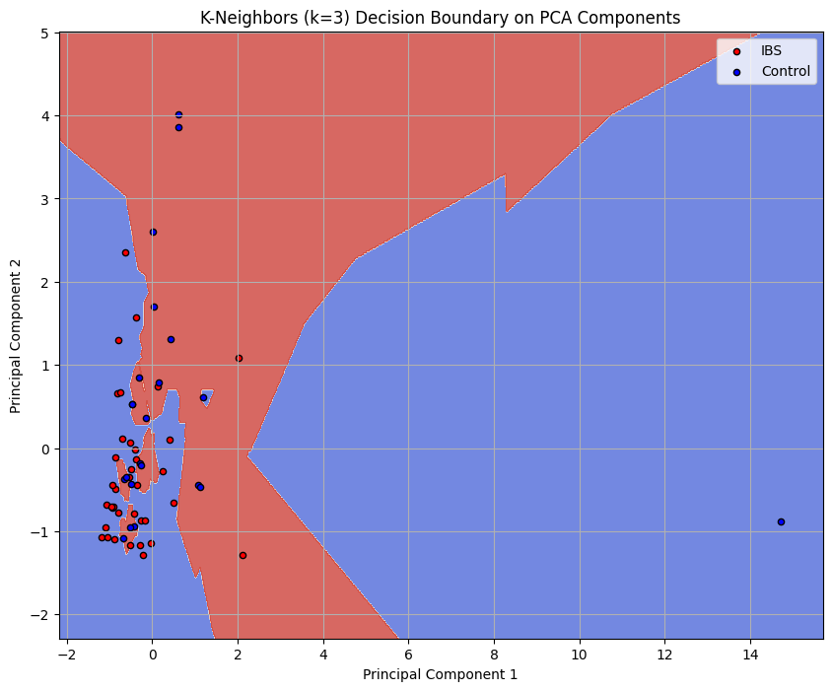

3. Machine Learning Classification Accuracy
Best LOOCV Accuracy for Random Forest: 0.7966
Best LOOCV Accuracy for Decision Tree: 0.7966
Best LOOCV Accuracy for K-Neighbors: 0.6441
Best LOOCV Accuracy for SVM (RBF Kernel): 0.7119
Best LOOCV Accuracy for Logistic Regression: 0.7119

4, Feature Importance

 | Feature | Importance
1 | spicy food | 0.289828
7 | seeds | 0.148810
6 | no lean meat | 0.121720
4 | flatulence | 0.076310
3 | raw food | 0.075891
8 | dressings | 0.067760
9 | whole grain | 0.058794
2 | fatty dairy | 0.057328
5 | acidic fruit | 0.054849
0 | fried food | 0.048710

5. Effect Size Analysis
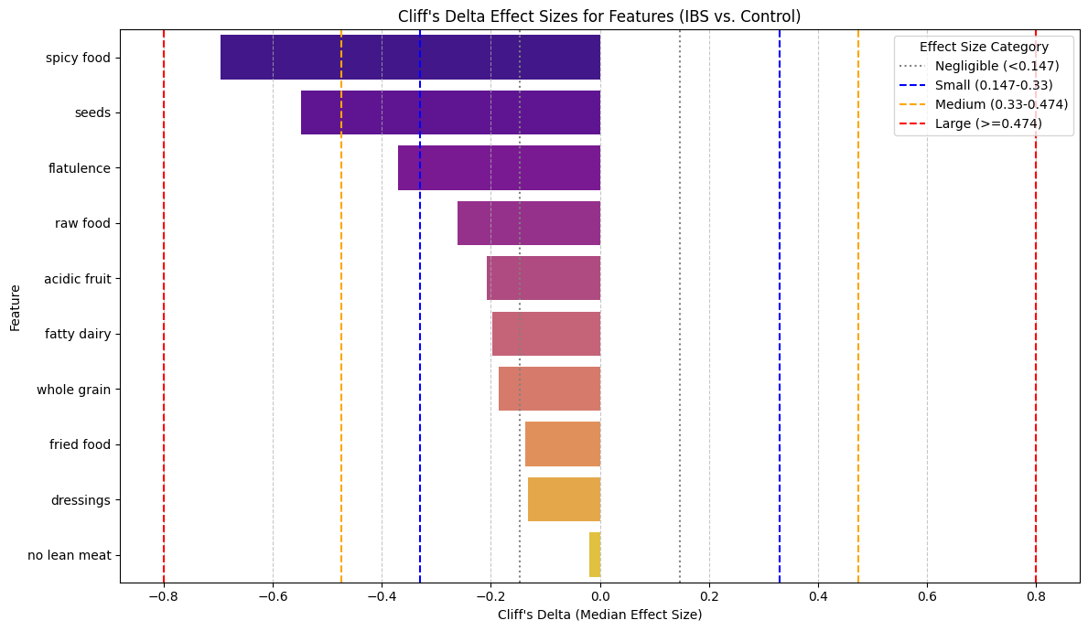
Effect Sizes for all Features: IBS < Control

Cohen's d (Mean Z-Score Effect Size):
  - Large Effect (|d| >= 0.8): spicy food (d = -0.99).
  - Medium Effect (0.5 <= |d| < 0.8): seeds (d = -0.59), dressings (d = -0.48).
  - Interpretation: The negative values indicate that the IBS group had lower mean values for these features compared to the Control group. The largest effect was observed for spicy food, indicating a substantial difference in consumption.
  - Clarification on 'Spicy Food': The mean 'spicy food' consumption for the IBS group was 3.71, compared to 23.79 for the Control group. This confirmed that IBS patients in this dataset consume significantly less spicy food, likely due to avoidance of symptom triggers.
Cliff's Delta:
  - Large Effect (|δ| >= 0.474): spicy food (δ = -0.69), seeds (δ = -0.55).
  - Medium Effect (0.33 <= |δ| < 0.474): flatulence (δ = -0.37).
  - Interpretation: Consistent with Cohen's d, Cliff's Delta highlighted spicy food and seeds as having large effect sizes, further supporting substantial differences in their distributions between the groups. The negative values again denote lower median values in the IBS group.
*** key Findings
- Dietary Avoidance as a Key Indicator: The strong and consistent signal from spicy food consumption, with IBS patients consuming significantly less, suggests that dietary avoidance behaviors are a prominent characteristic of the IBS population in this dataset. This isn't necessarily about spicy food causing IBS, but rather IBS patients reacting to or preemptively avoiding it due to symptom triggers. This aligns with clinical observations where many IBS patients identify and avoid trigger foods.

Explanation of the Finding
As you can see from the calculated means/medians, the IBS group actually consumes less spicy food than the Control group in this dataset. The negative effect sizes (Cohen's d = -0.99 and Cliff's Delta = -0.695) accurately reflect this direction, indicating that the IBS group has a lower mean/median for 'spicy food' consumption.
Your intuition that IBS patients might consume more spicy food could stem from an assumption that certain foods worsen symptoms, leading to increased consumption. However, it's also very common for individuals with IBS to avoid foods that trigger their symptoms. This data suggests that, for the participants in this study, the IBS group is actively limiting or avoiding spicy foods, resulting in lower reported consumption. This is a behavioral adaptation, not necessarily a higher intake causing the condition.

III. Dietary and Medical Condition Features
1. Medical Condition Data Preprocessing

2. Visualization
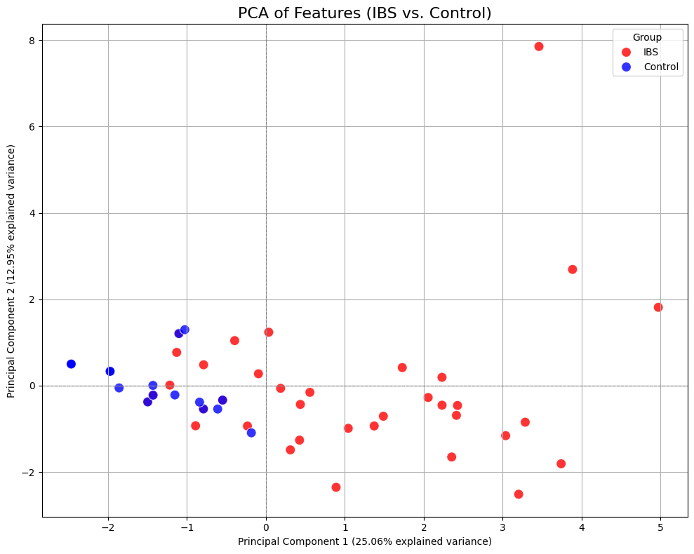

Summary Table:
Feature Name IBS yes IBS no Control yes Control no
0 smoke 4 34 0 21
1 alcohol 12 26 14 7
2 previous H.pylori infection 5 33 1 16
3 Present H.pylori infection 0 36 0 17
4 colonoscopy in the past 5 years 28 9 5 14
5 endoscopy in the past 5 years 24 12 5 15
6 hypertension 16 20 4 17
7 diabetes 11 26 1 20
8 high cholesterol 18 18 4 17
9 dx of depression 14 23 0 21
10 prescribed antidepressent 17 18 1 18
11 diagnosed with anxiety 20 16 1 20
12 PTSD dx 8 30 1 20
13 bipolar disorder dx 3 35 0 21
14 psychosis dx 1 37 0 21
15 drug use 6 32 0 21

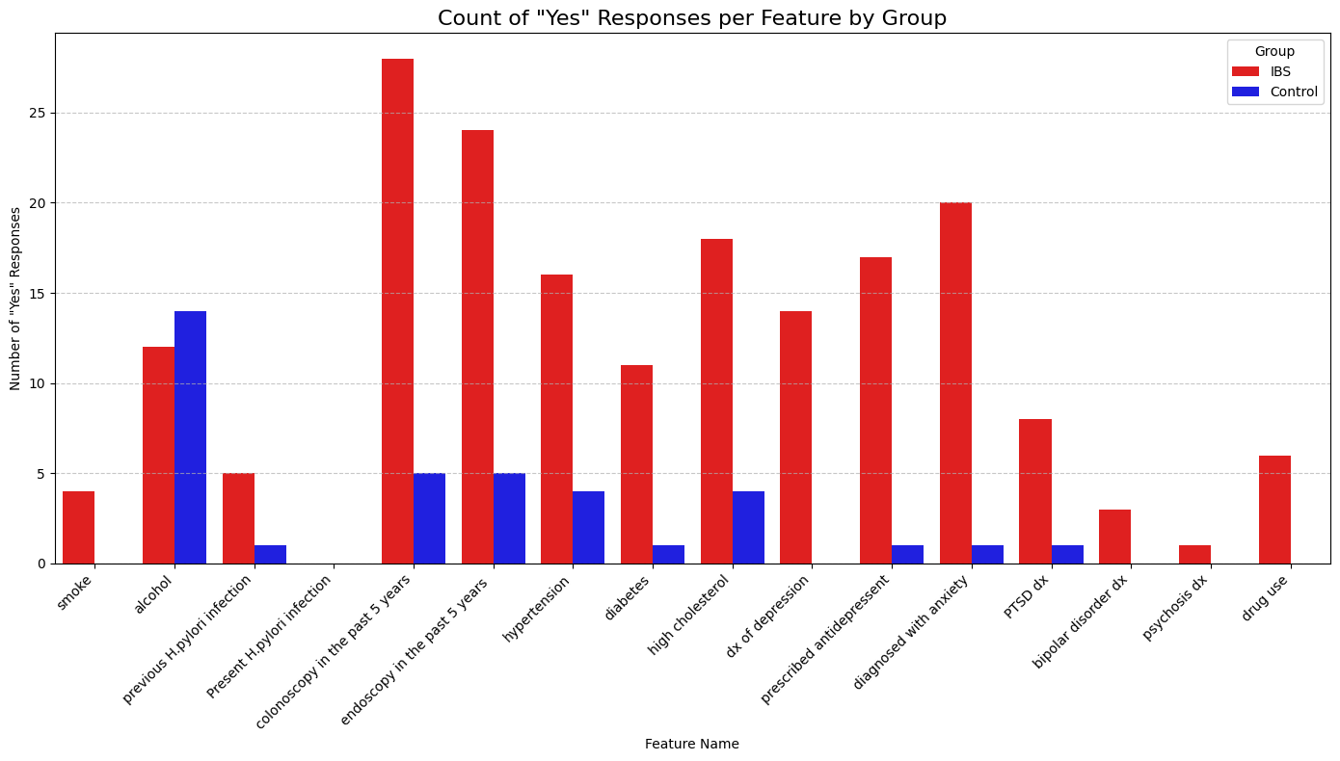

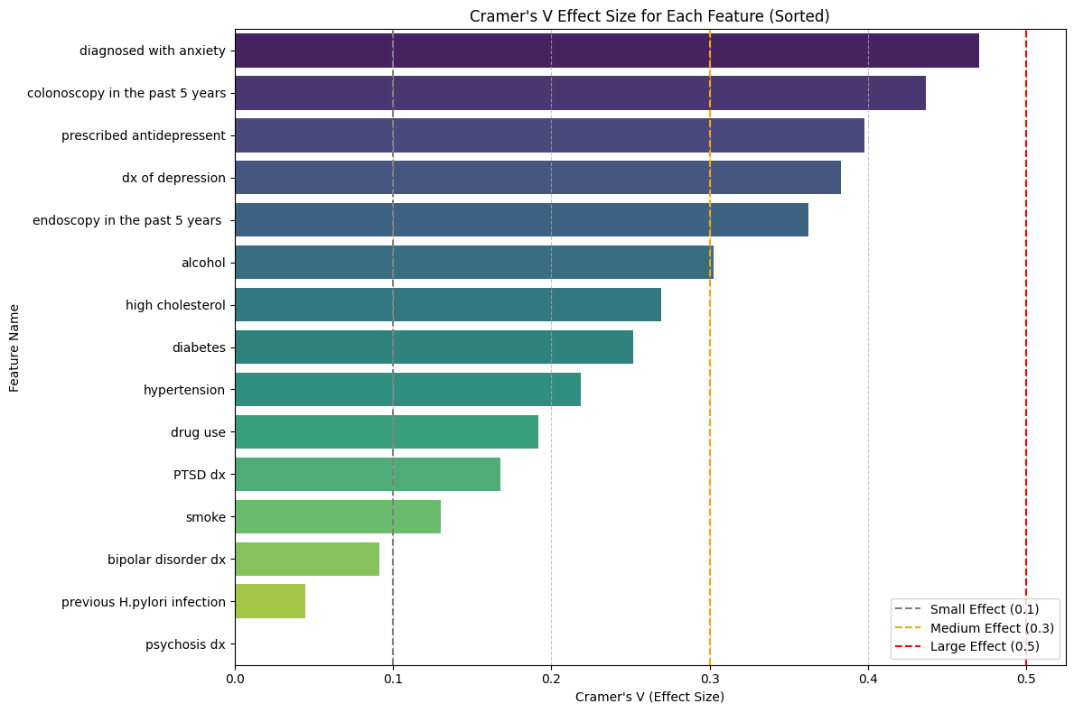

4. Classification
Classifier LOOCV Accuracy
K-Neighbors 0.745763
Logistic Regression 0.711864
SVM 0.711864
Random Forest 0.694915
Decision Tree 0.644068

5. Combined Feature Importance
Top Features by Random Forest Importance (Combined Data):
 | Feature | Importance
17 | spicy food | 0.179495
23 | seeds | 0.114834
11 | diagnosed with anxiety | 0.065732
20 | flatulence | 0.064593
4 | colonoscopy in the past 5 years | 0.060564
10 | prescribed antidepressent | 0.058591
24 | dressings | 0.056965
22 | no lean meat | 0.055835
21 | acidic fruit | 0.045147
19 | raw food | 0.044885
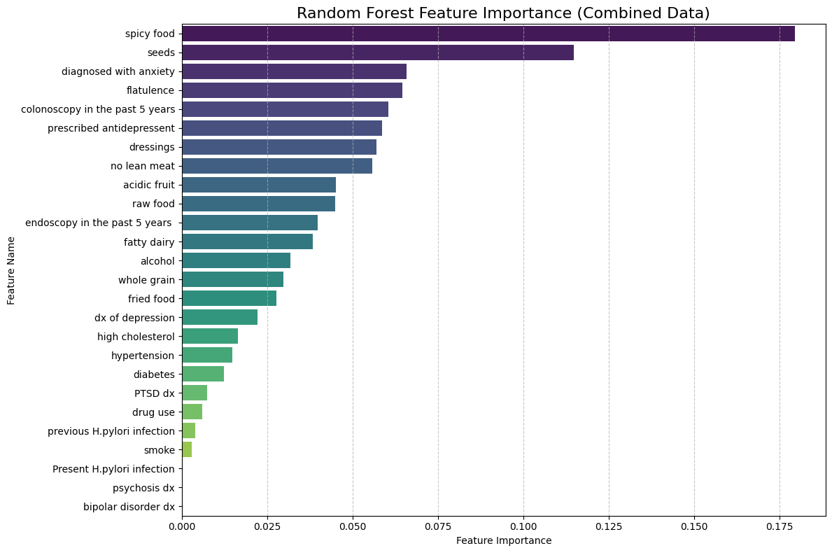
*Feature Importance:
Dietary Features > Medical Condition Features
IBS/Control Separation Factors
1. Dietary Habits
2. Anxiety, Depression
3. Other - Diabetes, Cholesterol, ….

Final Project Report: IBS vs. Control Classification based on Condition and Dietary Features

1. Introduction
This project aimed to differentiate between Irritable Bowel Syndrome (IBS) patients and healthy controls using a combination of medical condition and dietary features. The analysis involved data exploration, dimensionality reduction (PCA), and classification using various machine learning models with Leave-One-Out Cross-Validation (LOOCV). We also investigated feature importance to identify key differentiating factors and explored the statistical association of features with IBS.

2. Data Preparation and Exploration
Two datasets were used: MDRecord_Conditions_Analysis.xlsx (df1) containing medical conditions and MDRecord_Dietiary_Cleaned_forAnalysis.xlsx (df2) containing dietary habits. Missing values in df1 were imputed using the mode. Categorical 'yes'/'no' responses in both datasets were converted to numerical 1s and 0s for machine learning compatibility. Initial exploratory analysis included counting 'yes'/'no' occurrences for each feature by group and visualizing these distributions.

3. Principal Component Analysis (PCA)
PCA was performed on both the converted conditions data (df1_converted) and the dietary features (df2) to visualize group separation. While some separation was observed, particularly with df2, the plots indicated that a simple linear combination of two principal components might not fully capture the complexity of the group differences.
- df1_converted PCA: PC1 explained 25.06% and PC2 12.95% of the variance.
- df2 PCA: PC1 explained 42.20% and PC2 13.50% of the variance, showing a slightly better separation than df1_converted.

4. Classification and LOOCV Evaluation
Five machine learning classifiers (Random Forest, Decision Tree, K-Neighbors, SVM, and Logistic Regression) were evaluated using Leave-One-Out Cross-Validation (LOOCV) on three different feature sets:
- df1_converted (medical conditions)
- df2 (dietary features)
- Combined df1_converted and df2 features
LOOCV Accuracy Comparison:
Classifier | df1_Converted_Accuracy | df2_Accuracy | Combined_Accuracy
Random Forest | 0.6949 | 0.7966 | 0.8644
Decision Tree | 0.6441 | 0.7458 | 0.7966
K-Neighbors | 0.7458 | 0.6610 | 0.6610
SVM | 0.7119 | 0.6610 | 0.6610
Logistic Regression | 0.7119 | 0.6780 | 0.6949
Key Findings from Classification:
- Combined Data Superiority: The combined dataset consistently yielded the highest classification accuracies across all models, with Random Forest achieving the top performance at 0.8644. This strongly suggests that integrating both medical condition and dietary features provides a more robust basis for distinguishing between IBS patients and controls.
- Random Forest Performance: Random Forest demonstrated superior performance in all datasets, making it the most suitable model for this classification task.

5. Feature Importance Analysis (Combined Data)
To understand which features were most influential in the best-performing model (Random Forest on combined data), a feature importance analysis was conducted. The top features identified were:
- spicy food
- seeds
- diagnosed with anxiety
- flatulence
- colonoscopy in the past 5 years
- prescribed antidepressent
- dressings
- no lean meat
- acidic fruit
- raw food

6. Statistical Association using Cramer's V
Cramer's V, a measure of association for nominal variables, was calculated for each feature to quantify the strength of the relationship between individual features and the IBS/Control group.
Significant Associations (p < 0.05) with moderate to large effect sizes (Cramer's V):
- diagnosed with anxiety: (p=0.0004, Cramer's V=0.4702 - large effect)
- colonoscopy in the past 5 years: (p=0.0011, Cramer's V=0.4367 - moderate to large effect)
- prescribed antidepressent: (p=0.0035, Cramer's V=0.3976 - moderate effect)
- dx of depression: (p=0.0035, Cramer's V=0.3830 - moderate effect)
- endoscopy in the past 5 years: (p=0.0067, Cramer's V=0.3623 - moderate effect)
- alcohol: (p=0.0201, Cramer's V=0.3027 - moderate effect)
- high cholesterol: (p=0.0420, Cramer's V=0.2693 - small to medium effect)
These statistical associations largely corroborate the findings from the Random Forest feature importance, highlighting the importance of anxiety/depression related conditions and gastrointestinal diagnostic procedures.

7. Biomedical Implications
This analysis has several important biomedical implications:
- Holistic View of IBS: The significantly improved classification accuracy when combining medical condition and dietary features underscores the multi-faceted nature of IBS. It reinforces the understanding that IBS is not solely a gastrointestinal disorder but is often intertwined with psychiatric comorbidities and dietary triggers.
- Anxiety and Depression Link: The prominence of 'diagnosed with anxiety', 'dx of depression', and 'prescribed antidepressent' in both feature importance and Cramer's V analysis strongly supports the well-established gut-brain axis theory. Mental health conditions like anxiety and depression are frequently comorbid with IBS, and these findings suggest they are critical indicators for differentiating IBS patients.
- Diagnostic Procedures: 'Colonoscopy in the past 5 years' and 'endoscopy in the past 5 years' as important features could reflect the diagnostic journey of IBS patients, who often undergo these procedures to rule out other gastrointestinal conditions before receiving an IBS diagnosis. Their predictive power might indicate a history of seeking medical evaluation for persistent symptoms.
- Dietary Triggers: 'Spicy food' and 'seeds' emerging as top dietary features aligns with common clinical observations where certain foods act as triggers for IBS symptoms. This highlights the importance of dietary assessment in IBS management and diagnosis.
- Potential for Early Identification and Personalized Management: The high accuracy achieved by the Random Forest model on combined features suggests a potential for developing predictive tools that could aid in the early identification of individuals at high risk for IBS. This could lead to earlier intervention and more personalized management strategies, considering both the patient's medical history and dietary habits. For example, individuals with specific anxiety profiles and dietary sensitivities could be targeted for tailored advice or interventions.

8. Conclusion
By integrating medical condition and dietary features, this project demonstrated a robust ability to classify IBS patients from controls. The Random Forest model provided the best performance, and its feature importance analysis, supported by Cramer's V statistical associations, illuminated key biomedical factors, particularly the strong interplay between mental health, prior diagnostic efforts, and specific dietary patterns in IBS.
Further research could focus on validating these findings in larger, independent cohorts and exploring the causal relationships implied by these associations.

